BodegasEscudero

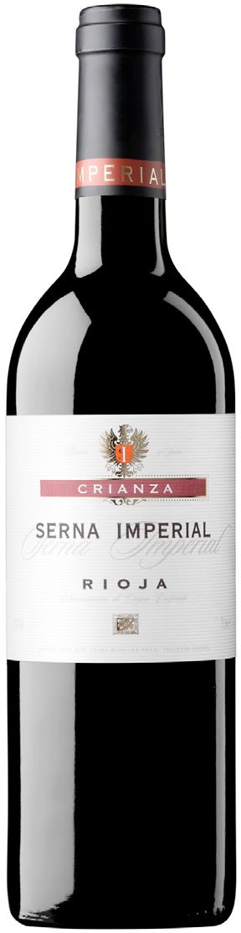
SERNA IMPERIAL
CRIANZA
DOC Rioja

VARIETALS
70% Tempranillo, 30% Garnacha.

ALCOHOL
13% Vol.

VINEYARDS AND HARVEST
Located on the south of Monte Yerga on the sunny side of the slopes, the Cuesta de la Reina Estate commences at an altitude of 450 meters and ascends to 800 meters. The soils, clayey­calcareous, are very poor and with abundance of boul­ ders. The estate of 120 Hectare has belonged to the family for four generations and the family itself has always cultivated the vineyard. The average age of the vines is over 50 years. Following a meticulous monitoring of the vineyard, the grapes are harvested at optimum maturity. The harvest is done manually by se­ lecting healthy and ripe grapes and rejecting the bad and deteriorated. The Har­ vest was done in mid­October for both the Tempranillo and the Garnacha grapes and at the end of Octber through the first week of September the Mazuelo.. The grapes are collected in fruit boxes to avoid any kind of crushing.

ELABORATION
Fermentation is done in stainless steel tanks with autochthonous yeasts. Upon completion of fermentation, the wine is macerated for at least 10 days. Aging is done in American oak barrels with an average of 5 years of age and remains there for at least 14 months. During this time, the wine is racked three times. Once the wine is clean, the wine is bottled and remains in the bottle cellar before going to market at least 6 months.

TASTING
Bright ruby red. Clean and complex on the nose, Harmony of fruit with notable hints of fine oak. Well structured on the palate, savory and balanced. The wine shows great character and has a long persistence. Complex retro nasal, elegant with notes of quality wood toasts.

FOOD MATCH
Accompanies perfectly with semi aged cheeses, red meat, roasts, stews and
game.

