SERNA IMPERIAL
Joven Tempranillo

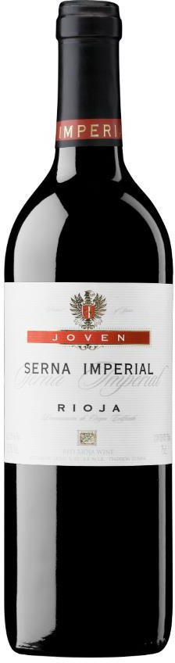

Grapes
100 % Tempranillo

Alcohol
12,5% - 13%

VINEYARDS AND HARVEST
Located in the south of Monte Yerga, the Finca Cuesta de la Reina is a hillside that begins at 450 meters high and rises to 800 meters. Its soils are clay-calcareous, poor and abundant, boulders, is a farm of more than 120 hectares that belong to the family for generations and in which the vineyard has always been cultivated.

ELABORATION
The grapes are collected in boxes of fruit to avoid any crushing in the transport and once in the cellar, they are emptied directly into the deposits where the grape clusters will remain in maceration for 12 days to later pass to the press, by means of a gentle pressing the skins and scrapes are separated from the must. This must finish fermenting slowly at low temperature. After that the wine is aging during 5 months in new american oak barrels.

TASTING
Pale red color with purple highlights that highlight his youth. Clean nose with aromas of small wild fruits, red and aniseed fruits. In the mouth it is elegant and with good structure, round, long with nice finish, fresh and fruity.

MATCH
Creamy cheese, charcuterie without much paprika and white meats cooked with creamy sauces.

